# PROJECT DEVELOPMENT PHASE

| **Date** | **28-06-2025** |
| --- | --- |
| **Team Id** | LTVIP2025TMID31256 |
| **Project Name** | **CRM Application for Jewel Management** |
| **College Name** | **Ideal Institute Of Technology** |

## **.Created developer org and explored platform features**

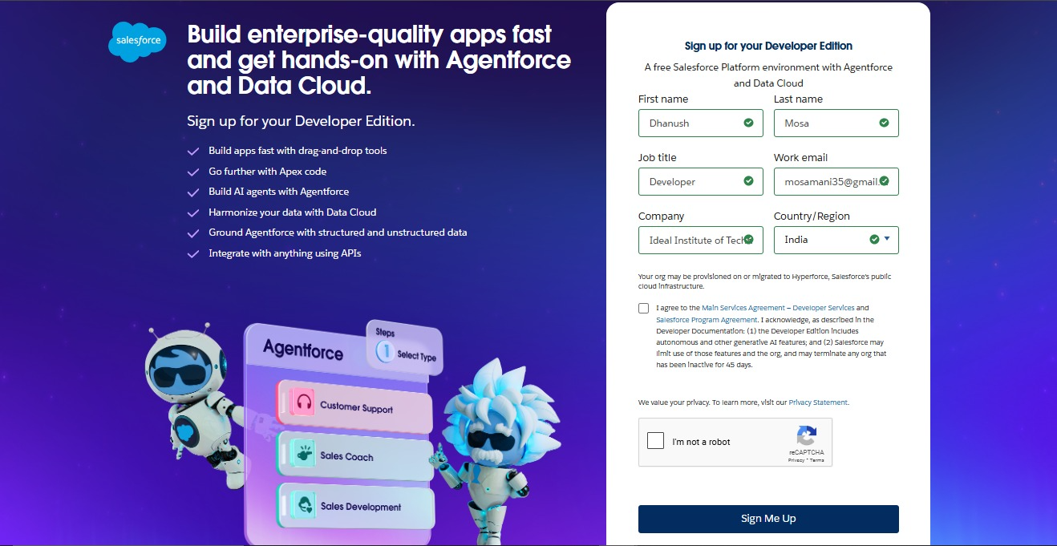

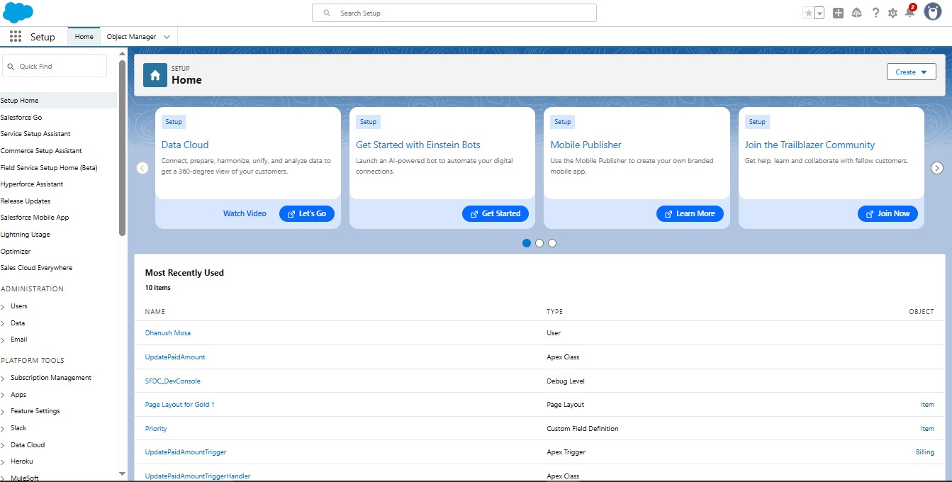

* **Created custom objects:Jewel Customer,Customer Order,Price,Billing,item**

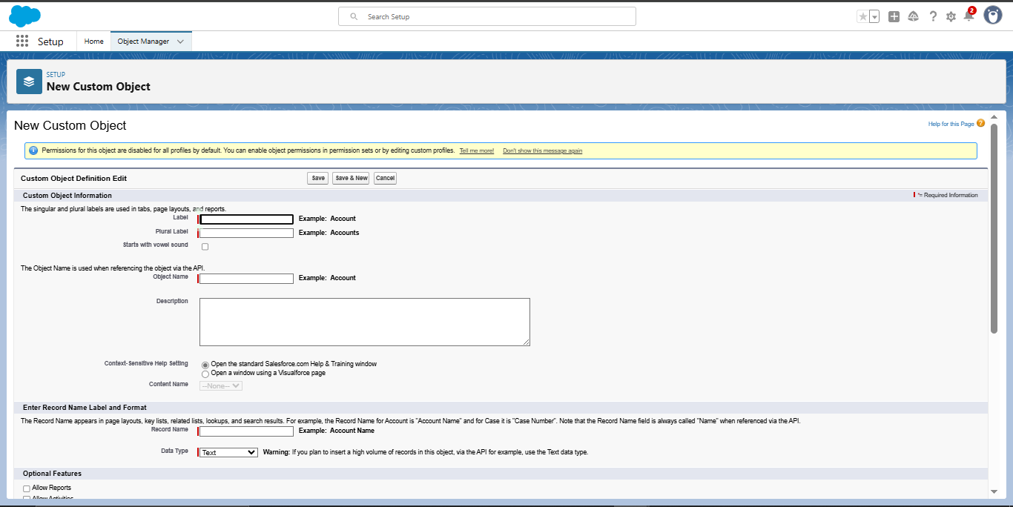

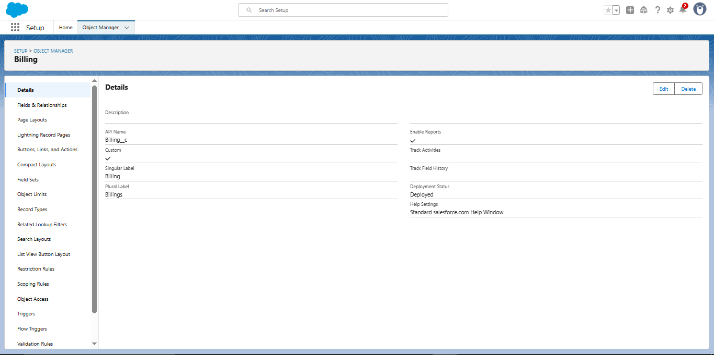

* **Created tabs for the custom objects**

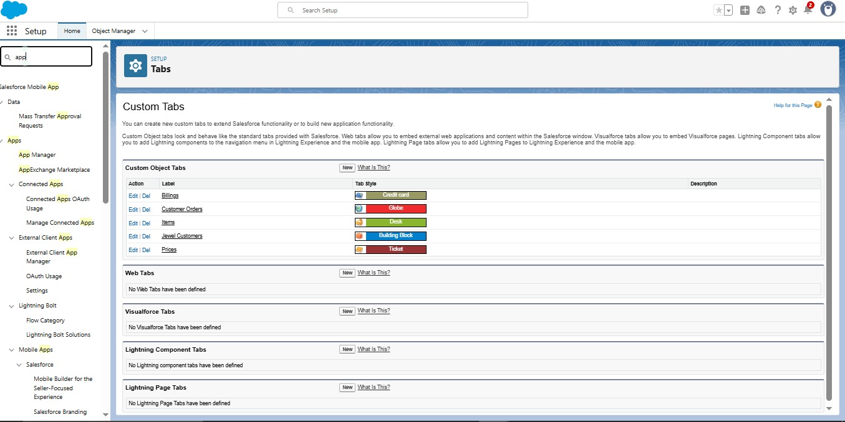

* **Developed a Lightning App**

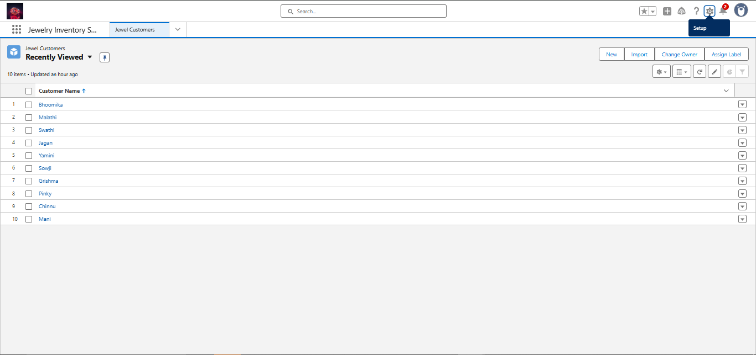

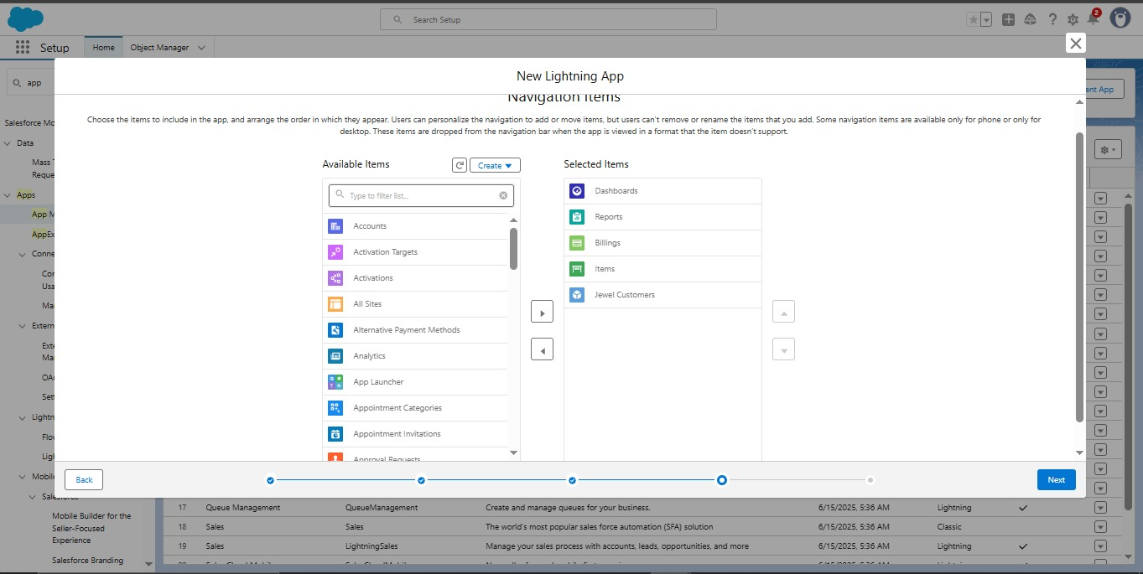

* **Create Fields for the objects.**

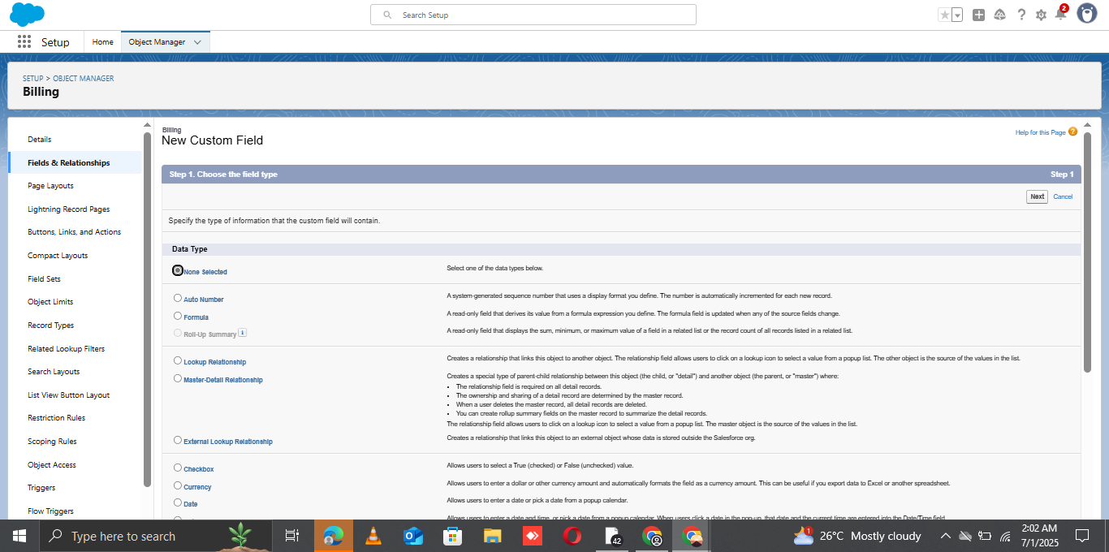

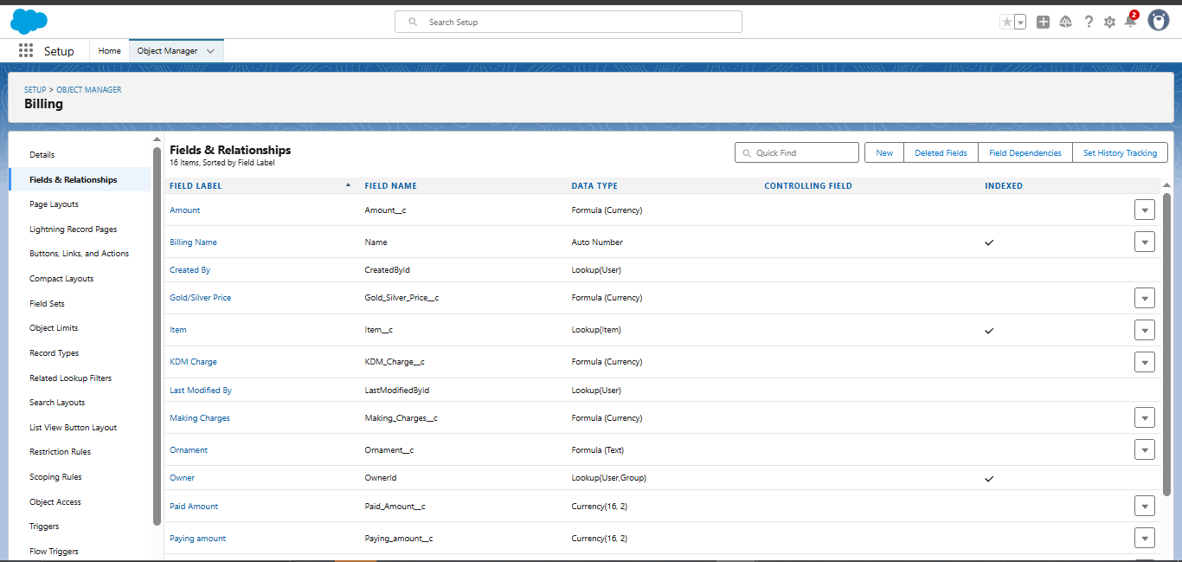

* **Schema Builder**
* The **Schema Builder** was used to visually design and manage the data model for the Field Service WorkOrder Optimization system in Salesforce. It provided a drag-and-drop interface to create and modify custom objects, fields, and relationships without needing code.

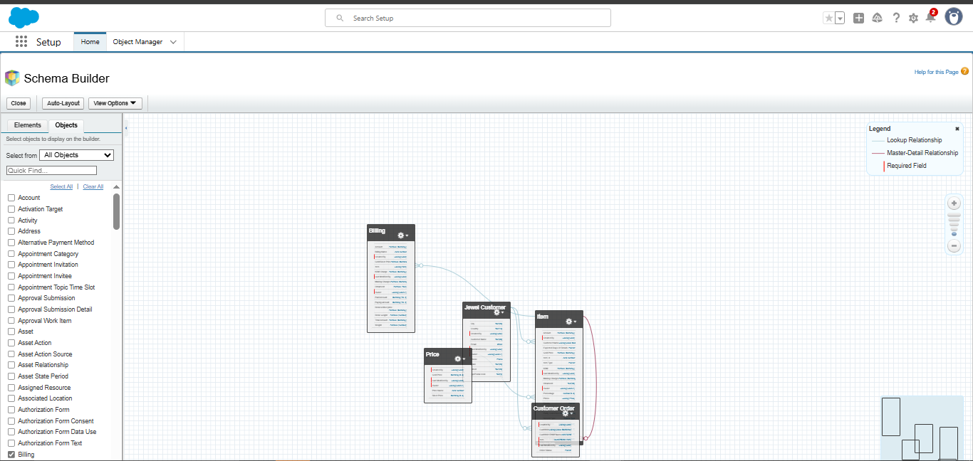

* **Created a Validation Rule for the Object**

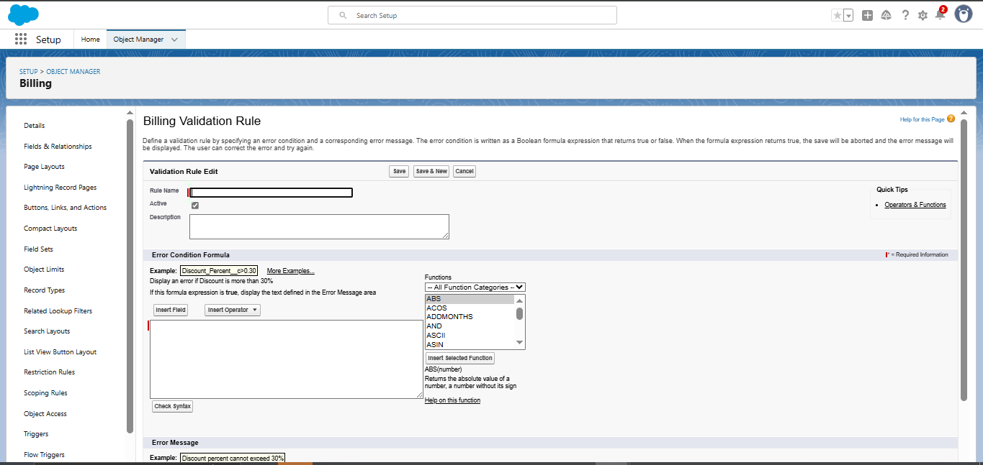

* **Created a profile**

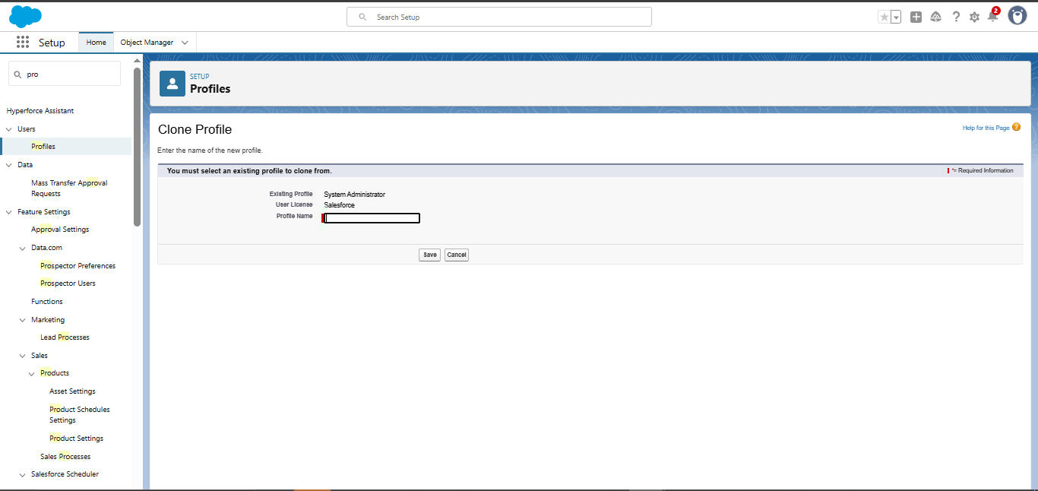

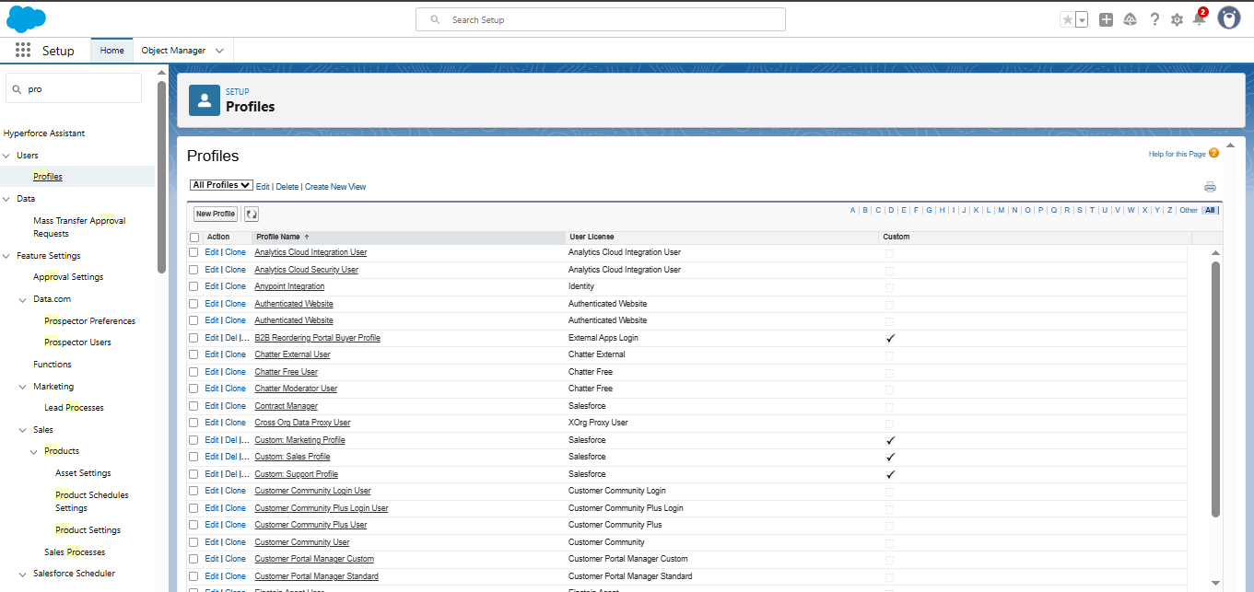

* **Create Goldsmith role**

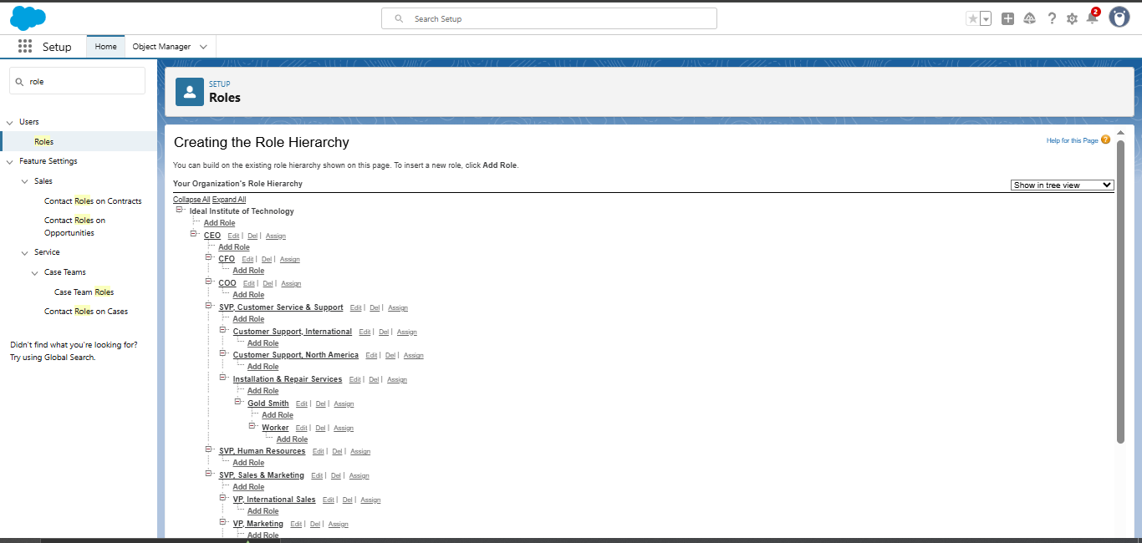

* **Created Users**

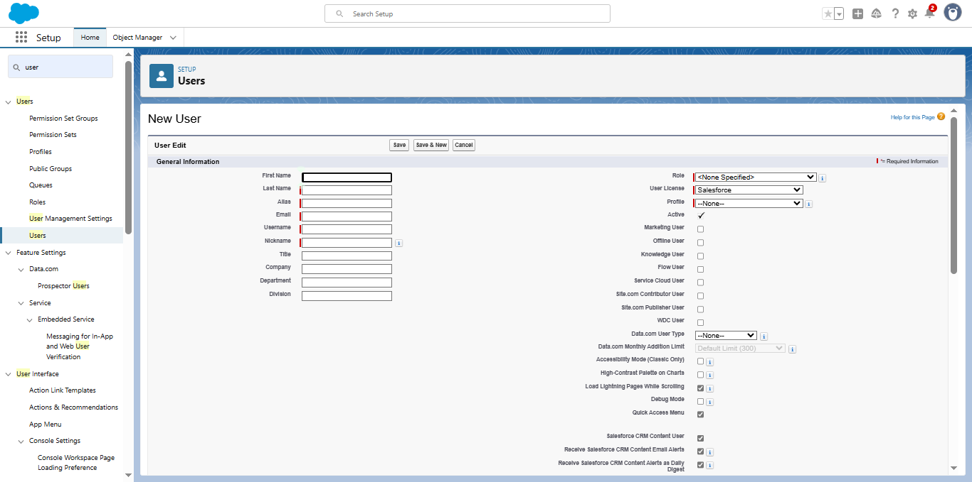

* **Create Page Layouts**

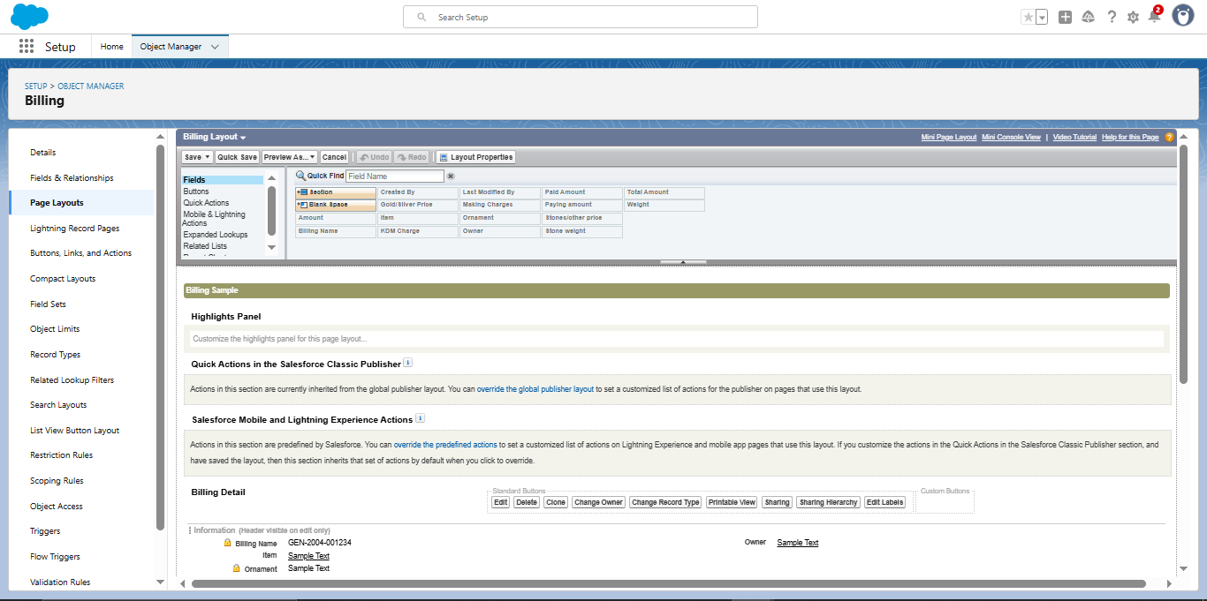

* **Create Record Type**

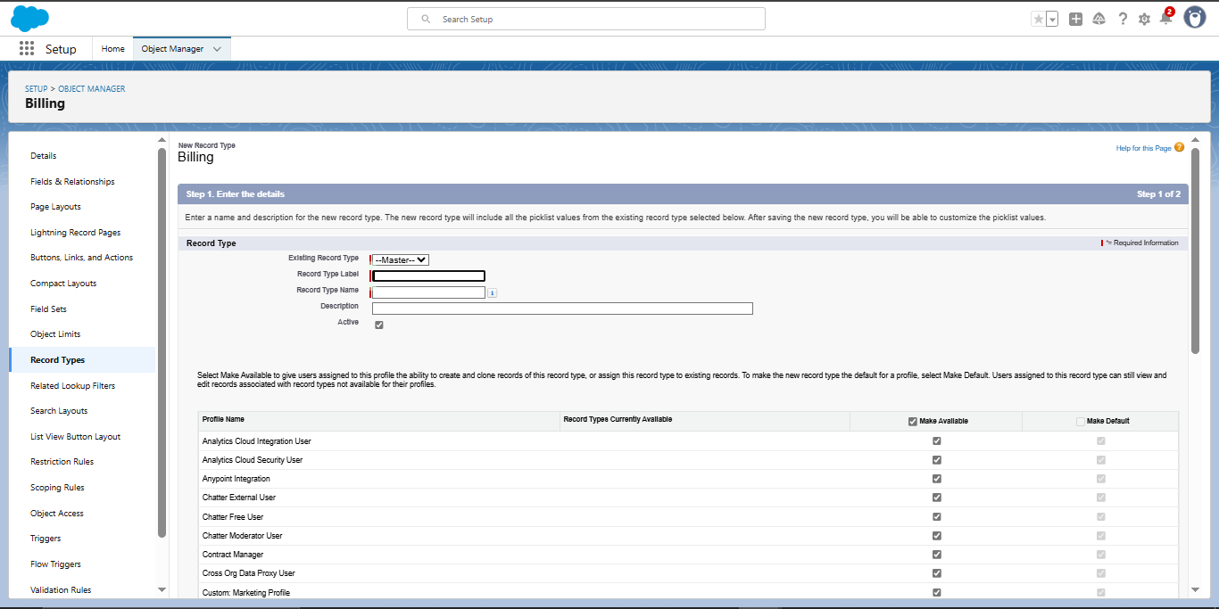

* **Create Permission Set**

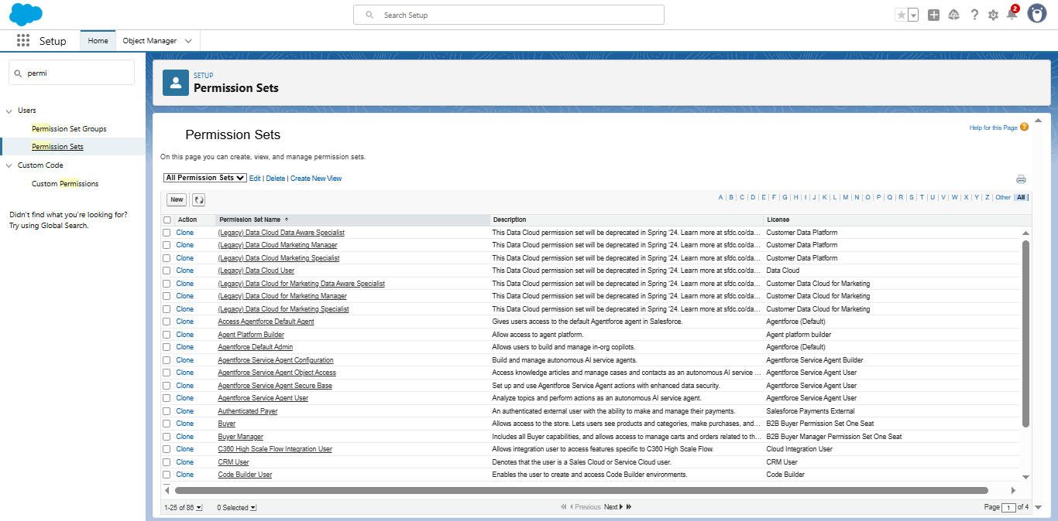

* **Create a Trigger Handler Class**

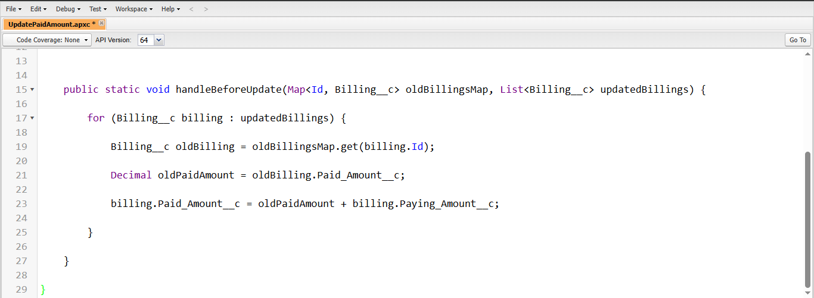

* **Create a Trigger**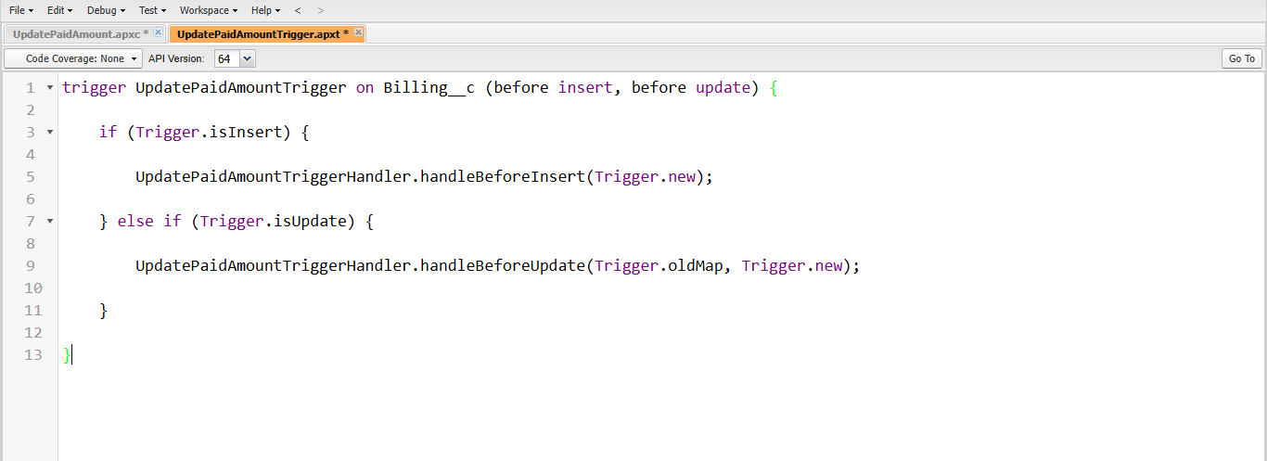
* **Create a Record**

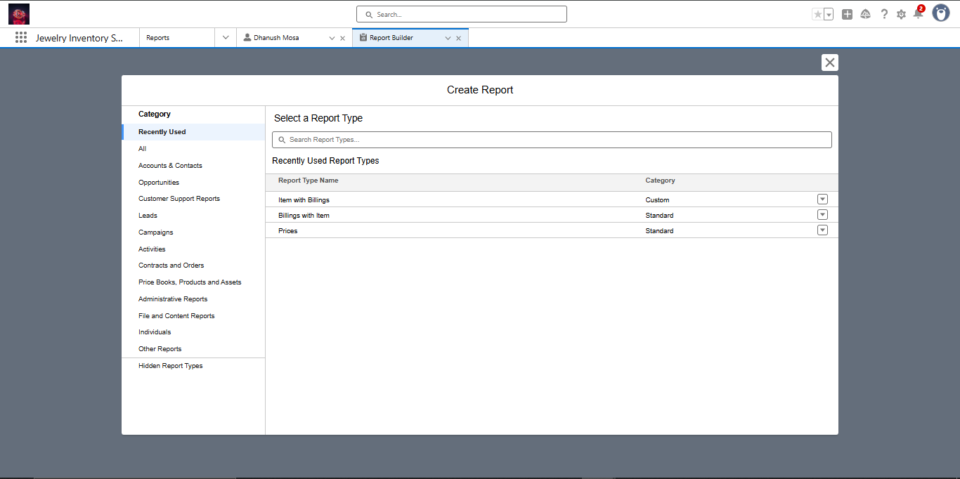

* **View a Record**

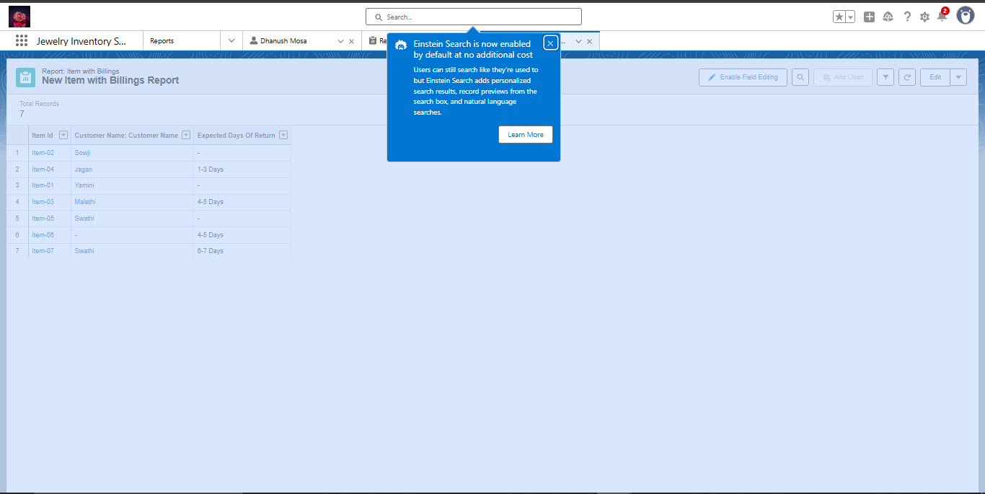

* **Create Reports**

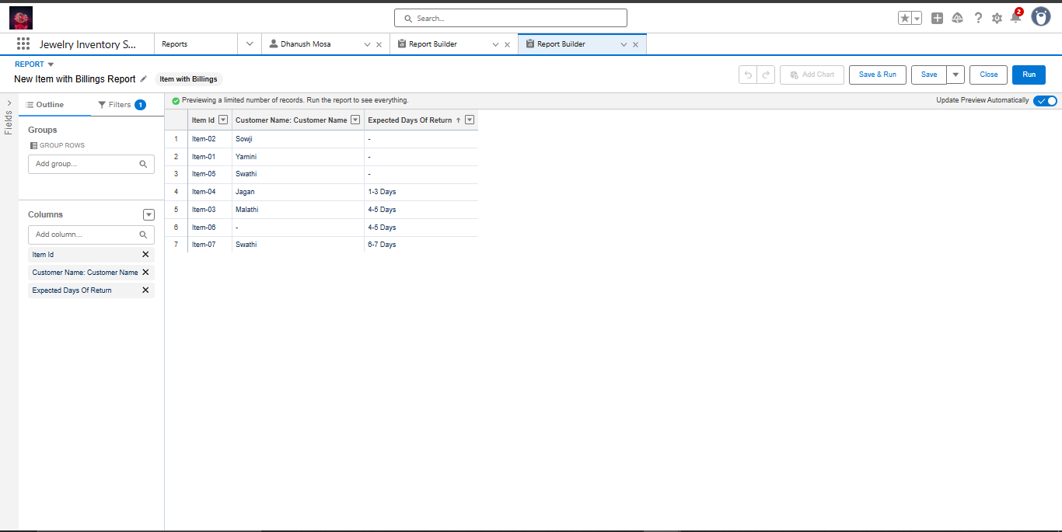

* **Create Dashboards**

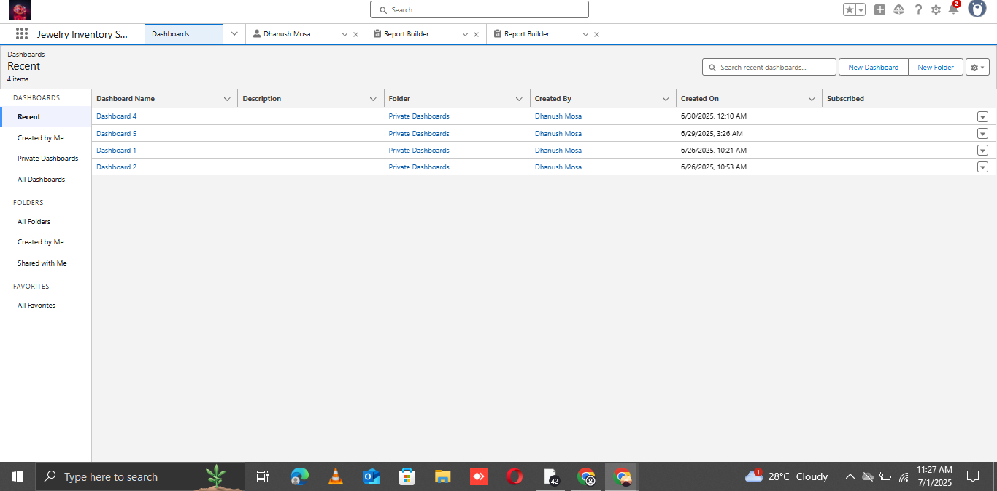

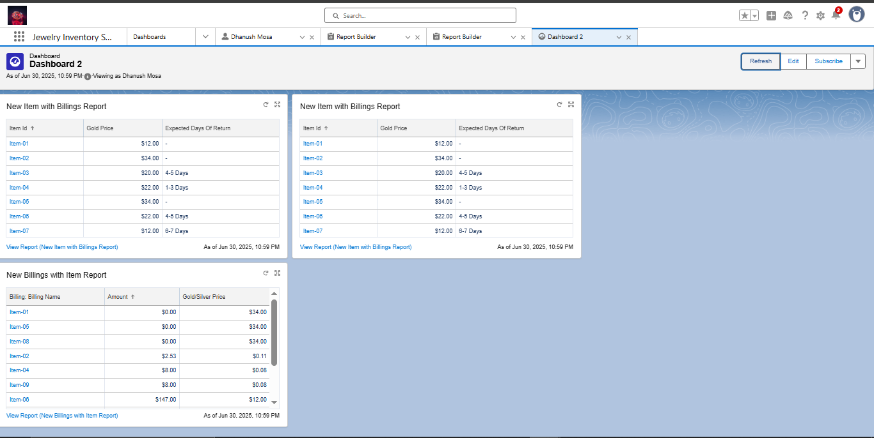

* **Create Flow**

